RACK IT UP

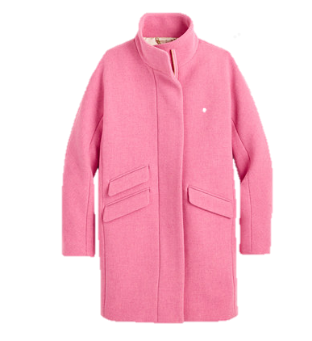Users can assemble a virtual closet as they shop online to help them stay on track for their monthly, seasonal or annual shopping budgets. Assemble links to your maybe-purchases and survey your virtual closet to decide whether to spend or save. The budget ticker updates as you add to and input the item’s price, and you can try out a virtual clothing rack to see how items pair together within outfits.

Total Aspirational Spending:

$678

|  |  |  |
| --- | --- | --- |
|  |  |  |
|  |  |  |